AI-Integrated Software Development SOP
Version 2.0 | February 2026 Optimized for: Lark + GitHub + GDrive | Team: 4-8 Devs (FE/BE split)

Executive Summary
This SOP defines the standard operating procedures for AI-integrated software development across 8 phases, mapping each phase to optimal AI models, agents, and tools for maximum automation while maintaining human oversight at critical decision points.

Model Selection Matrix (Jan 2026 Benchmarks)
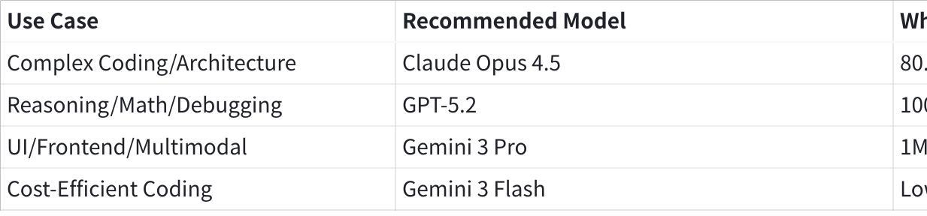
点击图片可查看完整电子表格

Tool Stack Overview
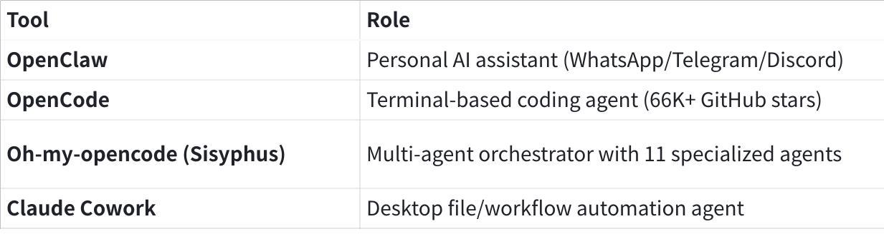
点击图片可查看完整电子表格

Phase 1: Project Initiation

Current Touchpoints
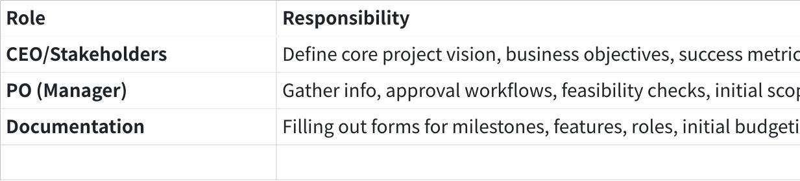
点击图片可查看完整电子表格

AI Revolution
AI Module: "The Architect Agent" — LLM-based Strategy Assistant
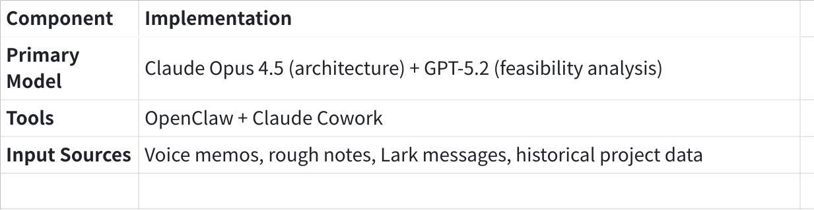
点击图片可查看完整电子表格
Interaction Flow:
- CEO provides raw voice memo or bulleted list via OpenClaw (WhatsApp/Telegram)
- OpenClaw transcribes and forwards to Claude Opus 4.5 for structuring
- AI analyzes historical project data (GDrive) and market trends (web search)
- Generates structured Project Charter and Basic Solution Brief instantly
- Claude Cowork organizes outputs into designated project folder
Automation Capabilities:
- Cross-references new requirements with past Feasibility Reports to flag technical debt
- Identifies resource conflicts before human review
- Auto-generates PRFAQ draft from vision statement
- Creates initial risk assessment based on similar past projects
- Suggests optimal team composition based on tech stack requirements
Workflow Gate:
Plain Text
┌─────────────────┐ ┌─────────────────┐ ┌─────────────────┐
│ CEO Voice/Text │────▶│ OpenClaw │────▶│ Project Charter│
│ via Telegram │ │ Transcribe + │ │ + Solution Doc │
└─────────────────┘ │ Route to Opus │ └────────┬────────┘
└─────────────────┘ │
▼
┌─────────────────┐ ┌─────────────────┐
│ Human Review │◀────│ Risk + Team │
│ (PO + CEO) │ │ Recommendations│
└─────────────────┘ └─────────────────┘
Human Checkpoint: PO reviews AI-generated charter with CEO before Phase 2 kickoff.

Phase 2: Research & Planning

Current Touchpoints
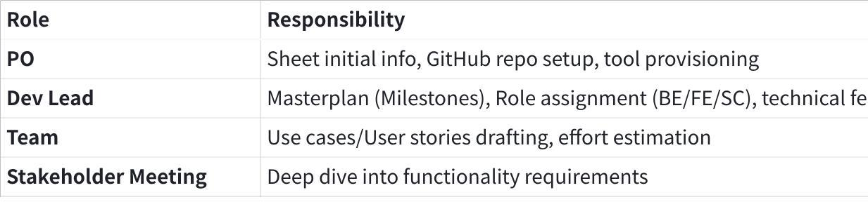
点击图片可查看完整电子表格

AI Revolution
AI Module: "Workflow Automator" — Integration Agent + Research Synthesizer
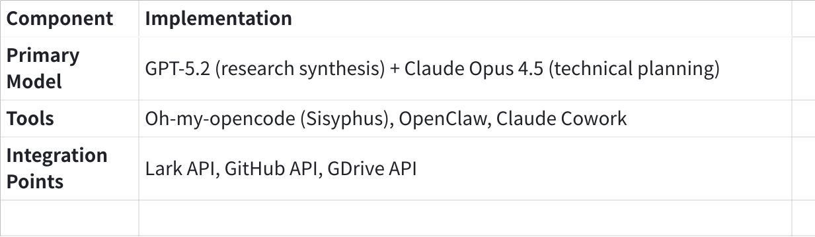
点击图片可查看完整电子表格
Interaction Flow:
- Once Architect Agent finishes brief, Sisyphus orchestrates parallel research:
- Librarian agent (Claude Sonnet 4.5): Searches existing codebases, docs, similar projects
- Oracle agent (GPT-5.2): Analyzes architecture patterns, suggests tech stack
- Auto-creates GitHub repo structure with AGENTS.md, proper branch protection
- Generates first draft of User Stories by analyzing project brief
- Creates Lark project workspace with task templates
Automation Capabilities:
- Reduces "Meeting to Documentation" time by 80%
- Auto-populates task templates based on identified User Stories
- Assigns initial labels and creates milestone structure
- Generates technical spike tickets for high-uncertainty areas
- Creates dependency graph for identified features
Sisyphus Delegation Pattern:
Plain Text
┌─────────────────────────────────────────────────────────────────┐
│ SISYPHUS ORCHESTRATOR │
│ (Claude Opus 4.5 + 32K thinking) │
├─────────────────────────────────────────────────────────────────┤
│ │
│ ┌──────────────┐ ┌──────────────┐ ┌──────────────┐ │
│ │ LIBRARIAN │ │ ORACLE │ │ EXPLORE │ │
│ │ Claude Sonnet│ │ GPT-5.2 │ │ Grok Code │ │
│ │ Doc research │ │ Architecture │ │ Codebase │ │
│ │ Examples │ │ Debugging │ │ Search │ │
│ └──────────────┘ └──────────────┘ └──────────────┘ │
│ │
│ ┌──────────────┐ ┌──────────────┐ ┌──────────────┐ │
│ │ FRONTEND │ │ ULTRABRAIN │ │ MULTIMODAL │ │
│ │ ENGINEER │ │ Claude Opus │ │ LOOKER │ │
│ │ Gemini 3 Pro │ │ Deep logic │ │ Image/PDF │ │
│ │ UI/UX work │ │ Architecture │ │ Analysis │ │
│ └──────────────┘ └──────────────┘ └──────────────┘ │
│ │
└─────────────────────────────────────────────────────────────────┘
Human Checkpoint: Dev Lead reviews auto-generated milestones and tech stack recommendations with PO.

Phase 3: Design & Architecture

Current Touchpoints
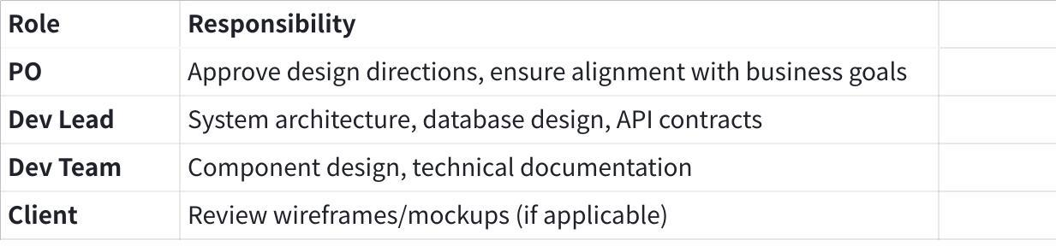
点击图片可查看完整电子表格

AI Revolution
AI Module: "Design Intelligence" — Architecture & UI Agent System
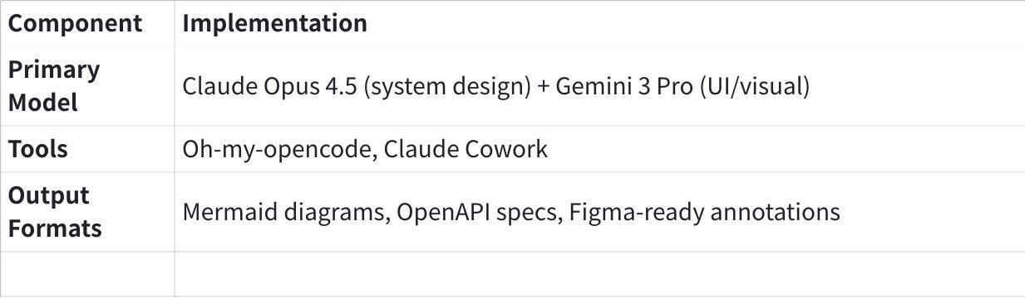
点击图片可查看完整电子表格
Interaction Flow:
- Dev Lead describes system requirements to Sisyphus
- Ultrabrain agent (Opus 4.5) generates:
- System architecture diagrams (Mermaid)
- Database schema recommendations
- API contract drafts (OpenAPI 3.1)
- Frontend Engineer agent (Gemini 3 Pro) produces:
- Component hierarchy
- State management recommendations
- UI/UX pattern suggestions based on requirements
Automation Capabilities:
- Generates ERD from natural language descriptions
- Creates sequence diagrams for complex flows
- Auto-documents API endpoints with examples
- Produces ADR (Architecture Decision Records) templates
- Validates design against OWASP security guidelines
Design Document Generation:
Plain Text
Input: "E-commerce platform with real-time inventory, payment processing,
and mobile-first responsive design"
Output:
├── architecture/
│ ├── system-overview.mermaid
│ ├── database-schema.sql
│ ├── api-contracts.yaml
│ └── ADR/
│ ├── 001-database-choice.md
│ └── 002-payment-integration.md
├── frontend/
│ ├── component-hierarchy.md
│ ├── state-management.md
│ └── responsive-breakpoints.md
└── security/
└── threat-model.md
Human Checkpoint: Architecture review meeting with Dev Lead + Senior Devs before implementation kickoff.

Phase 4: Development (Implementation)

Current Touchpoints
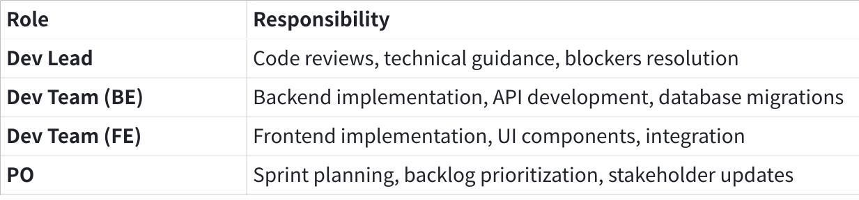
点击图片可查看完整电子表格

AI Revolution
AI Module: "Coding Swarm" — Multi-Agent Development System
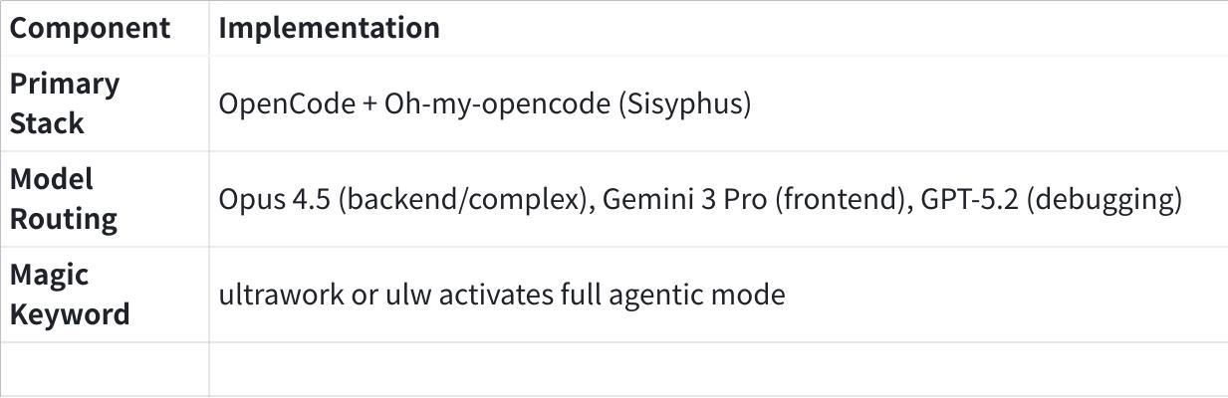
点击图片可查看完整电子表格
Interaction Flow:
- Developer describes task in natural language
- Sisyphus analyzes and delegates to appropriate sub-agents:
- Backend tasks → Oracle (GPT-5.2) for logic + Ultrabrain (Opus 4.5) for architecture
- Frontend tasks → Frontend Engineer (Gemini 3 Pro)
- Debug/fix → Oracle (GPT-5.2)
- Background agents run tests, lint checks in parallel
- Todo Continuation Enforcer ensures tasks complete end-to-end
Automation Capabilities:
- Auto-generates boilerplate code from specifications
- Creates unit tests alongside implementation
- Handles 8000+ ESLint warnings in a single day (verified case study)
- Converts local apps to SaaS web apps overnight
- Maintains coding standards via Comment Checker (prevents AI slop)
Development Workflow (Ultrawork Mode):
Plain Text
Developer: "ulw implement user authentication with OAuth 2.0,
JWT tokens, and refresh token rotation"
Sisyphus Response:
├── Delegating to Oracle for auth flow design...
├── Delegating to Ultrabrain for security review...
├── Creating background agent for test generation...
│
├── Implementation:
│ ├── src/auth/oauth-handler.ts
│ ├── src/auth/jwt-service.ts
│ ├── src/auth/refresh-rotation.ts
│ └── src/middleware/auth-middleware.ts
│
├── Tests:
│ ├── tests/auth/oauth.test.ts
│ └── tests/auth/jwt.test.ts
│
└── Documentation:
└── docs/auth-flow.md
Cost Optimization:
- Smart model routing saves 30-50% on tokens
- Use Gemini 3 Flash for simple refactors
- Reserve Opus 4.5 for complex architecture decisions
- Batch similar tasks to maximize context reuse
Human Checkpoint: PR reviews still require human Dev Lead approval. AI assists with automated review comments.

Phase 5: Quality Assurance & Testing

Current Touchpoints
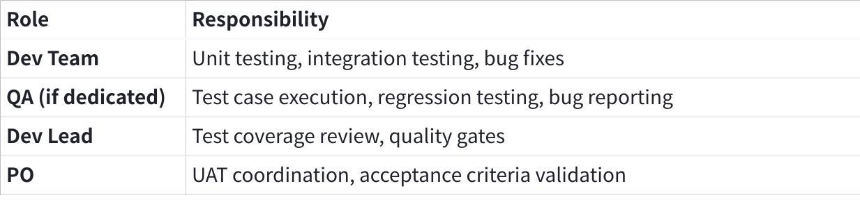
点击图片可查看完整电子表格

AI Revolution
AI Module: "Quality Guardian" — Automated Testing & Security Agent
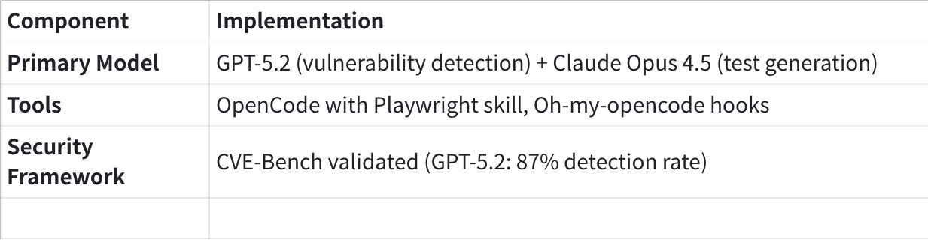
点击图片可查看完整电子表格
Interaction Flow:
- Auto-generated test suites from implementation code
- Playwright skill runs E2E tests automatically
- Security scan integrated into CI/CD pipeline
- AI triages failures, suggests fixes, auto-creates bug tickets
Automation Capabilities:
- Generates comprehensive test cases from user stories
- Creates edge case tests based on code analysis
- Performs automated security vulnerability scanning
- Generates test data with realistic patterns
- Produces test coverage reports with improvement suggestions
Security Testing Matrix:
Plain Text
┌─────────────────────────────────────────────────────────────────┐
│ GPT-5.2 SECURITY SCAN │
│ (CVE-Bench: 87% accuracy) │
├─────────────────────────────────────────────────────────────────┤
│ │
│ ✓ SQL Injection ✓ XSS Vulnerabilities │
│ ✓ CSRF Detection ✓ Authentication Flaws │
│ ✓ Dependency Audit ✓ Secrets in Code │
│ ✓ API Security ✓ Rate Limiting Gaps │
│ │
│ Output: security-report.md + auto-created Lark tickets │
│ │
└─────────────────────────────────────────────────────────────────┘
Quality Gates (Automated):
- [ ] Unit test coverage > 80%
- [ ] No critical/high security vulnerabilities
- [ ] All E2E tests passing
- [ ] Performance benchmarks within threshold
- [ ] Code review AI suggestions addressed
Human Checkpoint: PO conducts UAT with stakeholders. QA Lead signs off on release readiness.

Phase 6: Deployment & Release

Current Touchpoints
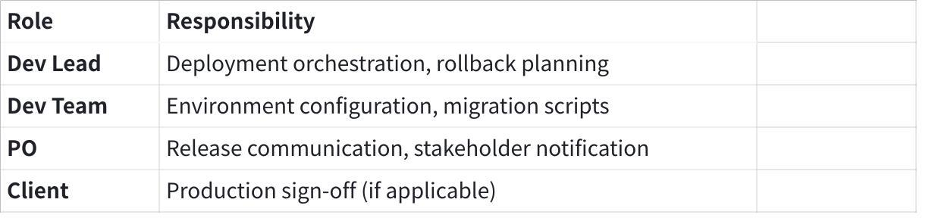
点击图片可查看完整电子表格

AI Revolution
AI Module: "Release Conductor" — Deployment Automation Agent
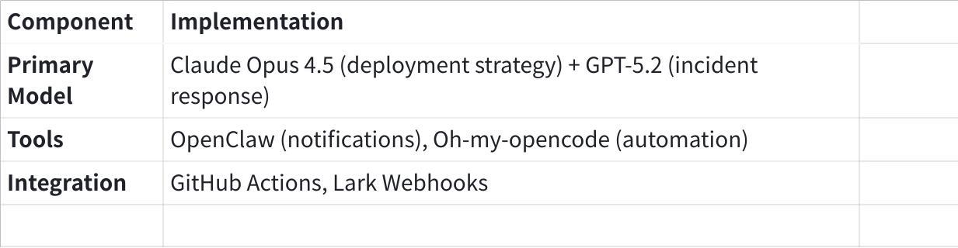
点击图片可查看完整电子表格
Interaction Flow:
- Dev Lead triggers deployment via Lark command or GitHub PR merge
- Sisyphus generates deployment checklist and runbook
- OpenClaw monitors deployment, sends real-time updates to team channels
- AI watches logs for anomalies, auto-alerts on issues
Automation Capabilities:
- Generates deployment runbooks from infrastructure code
- Creates rollback procedures automatically
- Monitors deployment health in real-time
- Auto-generates release notes from merged PRs
- Sends stakeholder-appropriate notifications via multiple channels
Deployment Pipeline:
Plain Text
┌─────────────┐ ┌─────────────┐ ┌─────────────┐
│ PR Merge │────▶│ AI Review │────▶│ Staging │
│ to main │ │ + Checklist│ │ Deploy │
└─────────────┘ └─────────────┘ └──────┬──────┘
│
┌─────────────┐ ┌──────▼──────┐
│ Production │◀────│ Health │
│ Deploy │ │ Checks OK │
└──────┬──────┘ └─────────────┘
│
┌──────▼──────┐
│ OpenClaw │
│ Notifies │
│ Lark/Slack │
└─────────────┘
Human Checkpoint: Final production sign-off by Dev Lead + PO before deployment execution.

Phase 7: Monitoring & Operations

Current Touchpoints
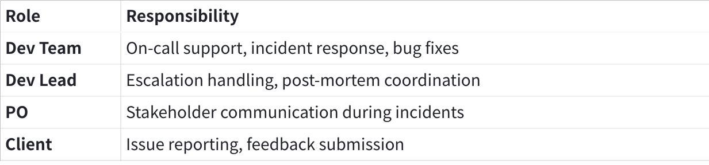
点击图片可查看完整电子表格

AI Revolution
AI Module: "Operations Sentinel" — Monitoring & Incident Response Agent
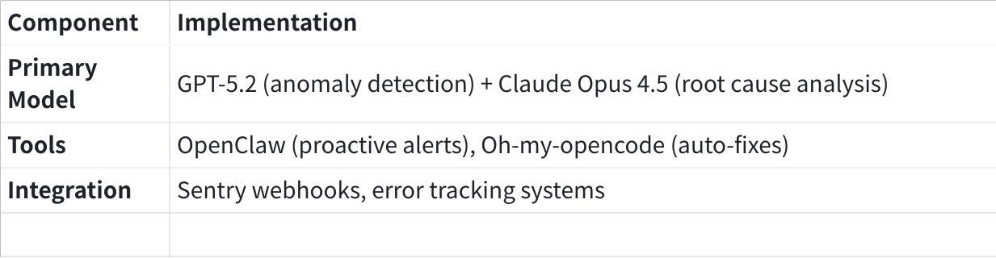
点击图片可查看完整电子表格
Interaction Flow:
- OpenClaw monitors error tracking (Sentry webhook integration)
- AI classifies severity, creates bug tickets automatically
- For known patterns, Sisyphus auto-generates fix PRs
- Escalates to human on-call for novel/critical issues
Automation Capabilities:
- Real-time error classification and prioritization
- Auto-generated incident reports
- Pattern matching against historical incidents
- Suggested fixes based on past resolutions
- Post-mortem template generation with timeline
Proactive Monitoring:
Plain Text
OpenClaw Configuration:
├── Sentry Integration
│ └── Webhook: Capture errors → AI classification → Auto-ticket
│
├── Heartbeat Checks
│ └── Every 15min: Health endpoint checks → Alert on failure
│
├── Performance Monitoring
│ └── Threshold breach → AI analysis → Suggested optimization
│
└── Security Monitoring
└── Suspicious activity → Immediate escalation + containment suggestion
Human Checkpoint: On-call engineer reviews AI-generated fixes before merge. Critical incidents require Dev Lead approval.

Phase 8: Maintenance & Iteration

Current Touchpoints
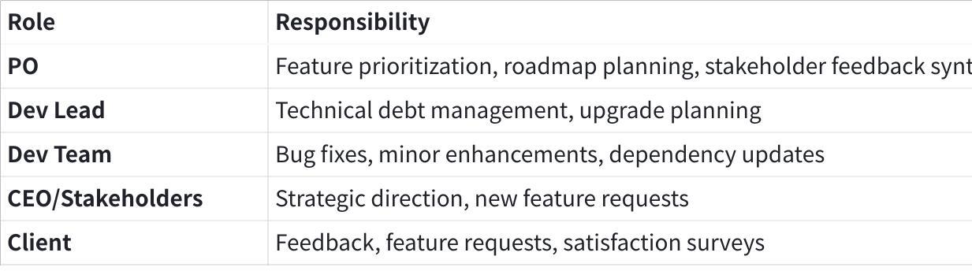
点击图片可查看完整电子表格

AI Revolution
AI Module: "Evolution Engine" — Continuous Improvement Agent
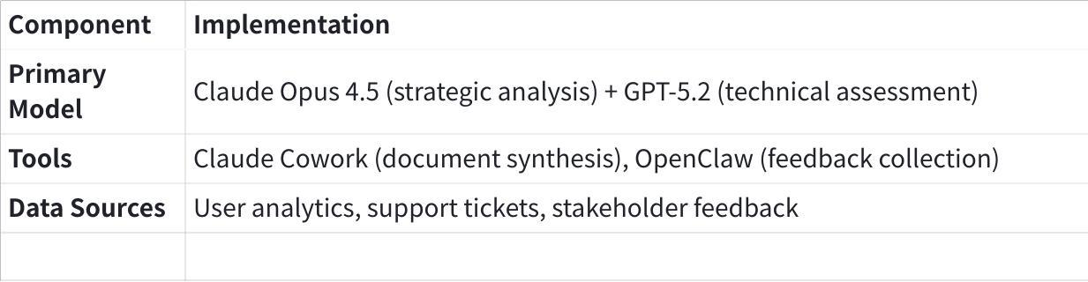
点击图片可查看完整电子表格
Interaction Flow:
- Claude Cowork aggregates feedback from multiple sources (Lark, email, support tickets)
- AI categorizes and prioritizes feature requests
- Generates quarterly roadmap draft based on business value + technical feasibility
- Sisyphus identifies technical debt and suggests refactoring priorities
Automation Capabilities:
- Synthesizes user feedback into actionable insights
- Generates product metrics dashboards
- Creates technical debt reports with ROI analysis
- Auto-drafts stakeholder update presentations
- Suggests optimal sprint capacity allocation
Continuous Improvement Loop:
Plain Text
┌─────────────────────────────────────────────────────────────────┐
│ EVOLUTION ENGINE CYCLE │
├─────────────────────────────────────────────────────────────────┤
│ │
│ ┌──────────┐ ┌──────────┐ ┌──────────┐ │
│ │ Collect │────▶│ Analyze │────▶│ Prioritize│ │
│ │ Feedback │ │ Patterns │ │ Features │ │
│ └──────────┘ └──────────┘ └────┬─────┘ │
│ │ │
│ ┌──────────┐ ┌──────────┐ ┌────▼─────┐ │
│ │ Measure │◀────│ Release │◀────│ Implement│ │
│ │ Impact │ │ Update │ │ Changes │ │
│ └────┬─────┘ └──────────┘ └──────────┘ │
│ │ │
│ └───────────────── Loop ────────────────────────────────┘
│ │
└─────────────────────────────────────────────────────────────────┘
Human Checkpoint: PO + CEO review AI-generated roadmap quarterly. Strategic decisions remain human-driven.

Appendix A: Tool Setup Quick Reference

OpenClaw Setup (PO/CEO)
Bash
# One-liner install
curl -fsSL https://openclaw.ai/install.sh | bash
# Onboard your assistant
openclaw onboard
# Connect to Telegram/WhatsApp via menu

OpenCode + Oh-my-opencode Setup (Dev Team)
Bash
# Install OpenCode
curl -fsSL https://opencode.ai/install | bash
# Install Oh-my-opencode plugin
bunx oh-my-opencode install
# Launch in project directory
opencode

Claude Cowork Setup (PO/PM)
- Download Claude Desktop for macOS
- Subscribe to Claude Max ($100-200/mo) or Pro ($20/mo)
- Click "Cowork" in sidebar
- Grant folder access to project directory

Appendix B: Model Cost Comparison (Jan 2026)
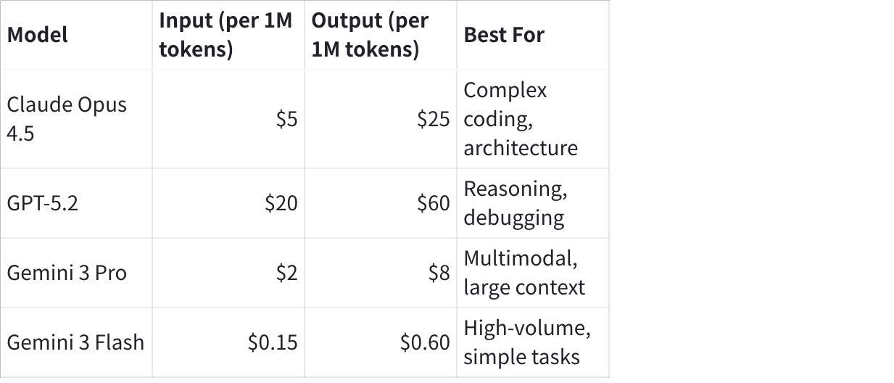
点击图片可查看完整电子表格

Cost Optimization Strategy
- Route 70% of requests to cheaper models (Flash/Sonnet)
- Reserve Opus 4.5 for architecture decisions only
- Use caching for repeated context
- Batch similar operations

Appendix C: AGENTS.md Template for Projects
Markdown
# AGENTS.md## Project Context- **Name**: [Project Name]
- **Tech Stack**: [e.g., Next.js, PostgreSQL, Redis]
- **Primary Language**: TypeScript
## Agent Permissions- **File Access**: Full read/write in src/, limited in config/
- **Shell Commands**: Allowed for testing, linting, building
- **External APIs**: Restricted to approved list
## Coding Standards- Follow existing patterns in codebase
- Run `pnpm lint` before committing
- Test coverage minimum: 80%
## Off-Limits- Do not modify .env files
- Do not push directly to main
- Do not delete production data

Appendix D: Security Considerations

Prompt Injection Prevention
- Sandbox all AI agents in containerized environments
- Limit folder access to designated project directories
- Review AI-generated code before execution in production
- Use OWASP LLM Top 10 (2025) as security baseline

Data Privacy
- No production credentials in AI context
- Use dummy data for AI testing
- Audit AI tool access quarterly
- Follow NIST AI RMF guidelines

Document History
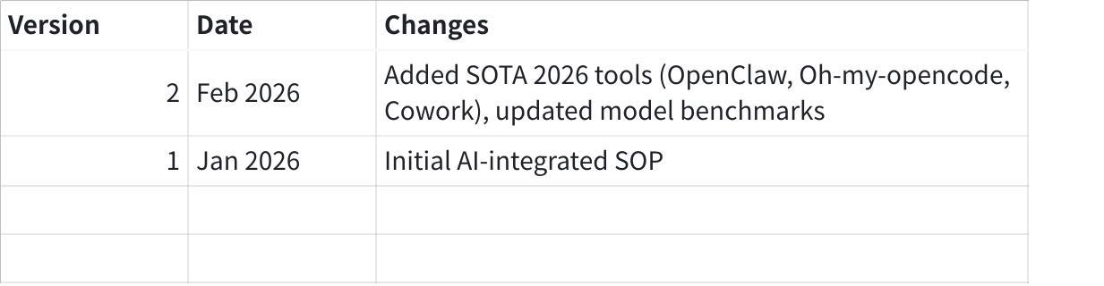
点击图片可查看完整电子表格

Document Owner: Product Owner
Review Cycle: Quarterly
Next Review: May 2026

Tap.fun Example:
Got it – I've updated the workflow accordingly with your instructions.

1. Executive Summary (tap.fun “Tap Trading” applied SOP)
Goal (from CEO/client): “Build something like Euphoria” (mobile-first, fun, one‑tap price prediction/trading UX). Euphoria positions “Tap Trading” as a mobile-first, game-like consumer trading experience and “one tap trading, in the palm of your hand.” (docs.euphoria.finance)
MVP we can ship fast (your current repo PRD direction): tap.fun Fortress Simulator = real-time “windowed one-touch” price-touch game on BTC, driven by live Binance data, with calibrated pricing + stable React UI; explicitly simulation only (no real-money gambling).
Core workflow contract (non-negotiables): Clarify Gate → Evidence Gate → decision boundaries → slice-based shipping (WorkGraph + progress logs).

2. Software steps (phases)
- Initiation (CEO request → product intent)
- Clarify + Scope Lock (MVP boundaries + “done” proof)
- Research + Spec (game mechanics, oracle, pricing, risk controls)
- Plan slices (milestones, owners, test plan)
- Build + Verify (incremental slices, evidence logs)
- Demo + Acceptance (proof pack)
- Change Control (no silent scope creep)
- Retro (skills + SOP improvement)

3. AI integration points (minimal, high leverage)
- After every meeting/chat: Decision/Questions/Actions summary (1 page)
- Before coding: Scope Lock draft + explicit assumptions + acceptance proof
- Spec phase: convert “tap trading UX” → testable mechanics (state machine + pricing + settlement)
- Planning: slice plan + WorkGraph tasks + verification commands
- Execution: status + evidence rollups from GitHub/Lark/Drive
- Acceptance: demo script + proof pack
- Change: Change Note draft + impact + updated scope
(Always: AI drafts/retrieves; humans approve/commit.) (microsoft.com)

4. Applied SOP by phase (tap.fun tap-trading)

4.1 Phase: Project Initiation (CEO request → intent brief)
Current Touchpoints
- CEO/Stakeholders: “Build like EuphoriaFi” (vision, urgency).
- PO: translate into a 1-page intent + options, avoid guessing.
- Dev Lead/Quant: not involved yet (avoid premature design).
AI Revolution
AI Module: “Intent Brief + Competitor Synth”
Interaction (inputs → outputs)
- CEO input to AI: 5 bullets (goal, target user, success, deadline pressure, risk tolerance).
- AI output:
- Intent Brief (1 page): outcome + constraints + unknowns
- “What to decide now” list (A/B/C)
Automation
- Pull key competitor language into a reference section (Tap Trading = “mobile-first game-like” + one-tap) to align vocabulary. (docs.euphoria.finance)
Why this works
- Prevents “build vibes.” Converts “like Euphoria” into decision points before anyone codes.

4.2 Phase: Clarify & Scope Lock (MVP boundaries + proof)
Current Touchpoints
- CEO/Stakeholders: choose MVP scope and what’s explicitly NOT happening.
- PO: writes Scope Lock + Acceptance Proof (client-safe).
- Dev Lead: feasibility check (quick).
AI Revolution
AI Module: “Scope Lock Generator (client-safe)”
Interaction
- PO inputs to AI: Intent Brief + repo constraints.
- AI outputs Scope Lock v1 that matches your current repo reality:
- In-scope (MVP demo):
- Real-time price-touch game on BTC
- Live Binance data integration
- Calibrated pricing engine
- Stable React UI
- Out-of-scope (explicit): real-money gambling; true HFT (UI render tick is 100ms).
- Acceptance Proof: “demo works + key checks pass + evidence recorded” (see Phase 6)
Automation
- Enforce Clarify Gate: no slice starts until success criteria + verification are explicit.
Why this works
- It matches your workflow rules (Clarify Gate) and prevents unbounded scope.

4.3 Phase: Research &, pricing, settlement)
Current Touchpoints
- Quant/Research: define pricing + settlement corre.
- Dev Lead: translate spec into implementable modules.
- PO: keep spec readable; keep decisions logged.
AI Revolution
AI Module: “Quant Spec Compiler + Risk Checklist”
Interaction
- Quant inputs to AI: “Windowed One-Touch” concept + constraints.
- AI outputs a spec that matches your PRD (already mostly written):
- Game: grid-based windowed one-touch (win if oracle touches band inside future window).
- Modes (band widths 20/50/100 and window ranges).
- Oracle/settlement uses 1s OHLC (high/low for touch settlement” issue).
- Quote/render tick:
- Pricing: Monte Carlo + Brownian-Bridge touch probability; calibration layer; risk cratio, liability haircuts). on
- Draft a “Spec → Test Matrix” (each mechanic maps to a test: unit/integration/scenario).
- Premortem (10 min): assume the launch deble failure causes; convert to mitigations. (Harvard Business Review)
Why this works
- “Auditability” comes from explicit settlement rules + test mapping; premortem surfaces hidden blockers early. (Harvard Business Review)

4.4 Phase: Plan slices (WorkGraph + verification commands)
Current Touchpoints
- Dev Lead: slices the build (backend stream, pricing engine, UI grid, bet flow).
- PO: ensures each sliceof.
- CEO: approves tradeoffs (fast vs safe).
AI Revolution
AI Module: “Slice Planner + WorkGraph Builder”
Interaction
- Dev Lead inputs: desired milestone + constraints (Flask + React Vite, Binance WS).
- AI outputs:
- Slice list + dependencies (WorkGraph)
- Verification commands per slice
- Evidence logging plan (progress files + merged Progress.txt)
Automation
- Auto-create GitHub issues/labels + Lark sprint tasks from slice plan (via your integration bot).
- Keep PRD.json small and current slice-by-slice (your workflow rule).
Why this works
- Controlled concurrency + explicit verification avoids multi-agent thrash and “it works on my machine.”

4.5 Phase: Build & Verify (evidence-driven)
Current Touchpoints
- FE: implements grid UX + tap flow.
- BE: SSE stream + bet API endst.
- Quant: validates pricing/calibration outputs.
- PO: wants truth without reading code.
AI Revolution
AI Module: ot + Evidence Reporter”
Interaction
- Dev inputs to AI: slice task + allowed paths + verification commands.
- AI outputs: diffs + test updates + run outputs (captured in progress logs).
Automation
- Enforce Evidence Gate: never mark acceptance as pass without command evidence + touched files logged.
- Failure triage: harness/env vs logic bug vs spec mismatch (prevents infinite loops).
Concrete verification anchors (from PRD)
- Backend run: PYTHONPATH=. python3 -m src.server (Binance live by default).
- Strategy tests: python3 fortr:contentReference[oaicite:34]{index=34}s.py --max-ticks 10000 --modes 20.
- Frontend: npm run dev in `
Why this works
- “Proof” is repeatable commands + logs, not opinions. (Evidence Gate baseline.) Phase: Demo / Acceptance (Proof Pack)
Current Touchpoints
- CEO/Stakeholders: wants a conhoria’s “tap trading” feel.
- PO: runs denks; locks “done.”
- Dev Lead: supports if issues.
AI Revolution
AI Module: “Demo Script + Proonteraction
- PO inputs: Scope Lock + Acceptance checks.
- AI outputs Proof Pack (client-safe):
- Demo script (tap grid, place bet basket, show settlement)
- Evidence links: commands run + outputs
- Known limitations (e.g., simulation-only, live Binance dependency)
Why this works
- Matches Euphoria-style “tap trading” narrative (fun, one tap) but anchored in evidence and explicit limitations. (docs.euphoria.finance)

4.7 Phase: Change Control (no silent creep)
Current Touchpoints
- CEO: “Add ETH”, “add staking vault”, “add wallet login”, “make it real money.”
- PO: must convert change into impact and choice.
- Dev Lead: estimates and risk signal.
AI Revolution
AI Module: “Change Note Automator (impact + options)”
Interaction
- PO inputs change request.
- AI outputs: Change Note with A/B/C options + impact (time/risk/scope).
Automation
- Decision boundary enforced: AI does not change dependencies/security posture unilaterally; it presents options and asks the decision-maker.
Why this works
- Prevents stealth scope; keeps commitments honest.

4.8 Phase: Retro (repeatable improvement)
Current Touchpoints
- PO + Dev Lead: what caused thrash? what reduced rework?
- CEO: approves process tweaks if needed.
AI Revolution
AI Module: “Friction Miner → Skills Learned”
Interactirecurring failures; proposes template/preset tweaks.
Automation
- Append to Efficiency/Retro logs; promote stable fixes into “Skills Learned” (your workflow evolution loop).
Why this works
- Converts pain into reusable “how we work” improvements instead of repeating mistakes.

5. Minimal measurement (compare to baseline)
Delivery performance (industry standard)
- Use DORA delivery metrics (5-metric model) for outcomes. (dora.dev)
Tap-trading product workflow (PO/CEst → Scope Lock approved” time
- “Scope Lock → demo” time

scope changes without Change Note (should be 0)

acceptance disputes (should trend down)

Evidence Gate violations (should be 0)

Optional: competitor alignment (what “like Euphoria” concretely means)
- “Tap Trading” framed as a fun, mobile-first, game-like experience; one-tap trading phrasing. (docs.euphoria.finance)
- Euphoria described as gamified mobile-first derivatives app on MegaETH with one-touch “tap trading” interface (context only, not a requirement). (crypto-fundraising.info)

